**Experiment: 2**

**Aim:** Give PEAS descriptor and identify properties of task environment and type of agent for given problems

**Objective:** To make students understand what is intelligent agent and how to design it.

**Description :**

PEAS description

Artificial intelligence is the science and engineering of making intelligent machines, especially intelligent computer programs. It is related to the similar task of using computers to understand human intelligence.

Artificial intelligence is the search for a way to map intelligence into mechanical hardware and enable a structure into that system to formalize thought. No formal definition, as yet, is available for as to what artificial intelligence actually is.

There are numerous definitions of what artificial intelligence is. We end up with four possible goals:

1. Systems that think like humans (focus on reasoning and human framework)

2. Systems that think rationally (focus on reasoning and a general concept of intelligence)

3. Systems that act like humans (focus on behaviour and human framework)

4. Systems that act rationally (focus on behaviour and a general concept of intelligence)

Artificial intelligence has successfully been used in a wide range of fields including medical diagnosis, stock trading, robot control, law, scientific discovery, video games, toys, and Web search engines.

**Performance Measure**

Specified by outside observer or evaluator

Applied (consistently) to (one or more) IAs in given environment

**Environment**

Reachable states

“Things that can happen” “Where the agent can go” To be distinguished (TBD) from: observable states

***Actuators***

What can be performed

Limited by physical factors *and* self-knowledge

**Sensors**

What can be observed

Subject to error: measurement, sampling, post processing

Example:

**Solved example for PEAS**

|  |  |  |  |  |
| --- | --- | --- | --- | --- |
| System | **Performance Measure** | **Environment** | ***Actuators*** | **Sensors** |
| Factory Floor Scheduling | Manufacturing enterprise integration, supply chain management, manufacturing planning, scheduling and execution control, materials handling and inventory management | Factory, Factory Equipment, Website, Suppliers, Customers, shippers | Display to user, Fill in demand form, Schedule resources, Count materials | Wireless communication, generic interface interconnections, manufacturing control architecture, Web pages |
| Image Analysis | Correct Image Categorization | Web pages, png, jpeg | Display Categorization of Scene | Color Pixels Array |
| Mail delivery Robot | speed, multi media attachment, accuracy, integrity, sharing, failure detection | Website | Network, display of mail | Keyboard |
| Web Crawler Soft Port | Number of pages analyzed per second, Accurate results | World Wide Web | Network, Display of results, Webpages, | Keyboard |

**Solved example for Determine environment Characteristics:**

|  |  |  |  |  |  |  |
| --- | --- | --- | --- | --- | --- | --- |
| System | Observable | Deterministic/  Stochastic | Episodic / Sequential | Static/ Dynamic | Discrete/ Continuous | Agents |
| Image Analysis | Fully | Deterministic | Episodic | Semi | Continuous | Single |
| Factory Floor Scheduling | Partial | Stochastic | Sequential | Dynamic | Continuous | Single |
| Mail Delivery Robot | Fully | Deterministic | Episodic | Semi | Continuous | Single |
| Web Crawler Soft Port | Fully | Stochastic | Sequential | Dynamic | Continuous | Single/Multi |

SIMPLE REFLEX AGENT

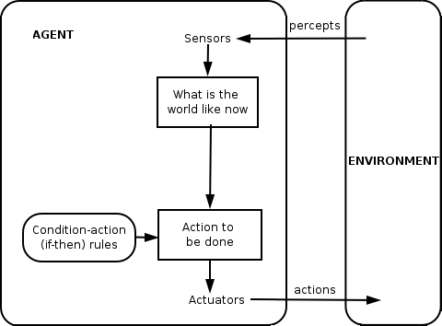

MODEL BASED REFLEX AGENT

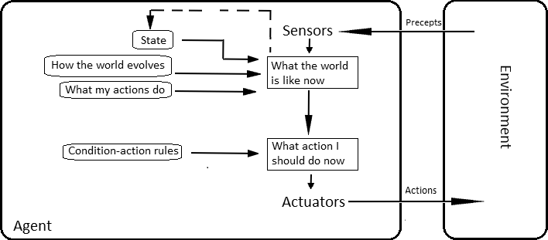

GOAL BASED AGENT

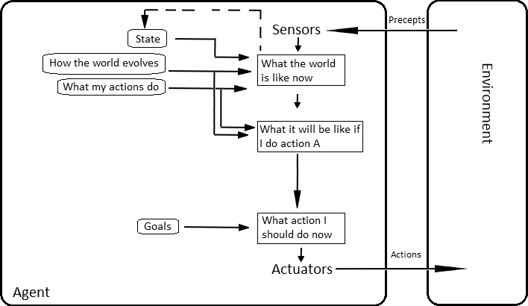

UTILITY BASED AGENT

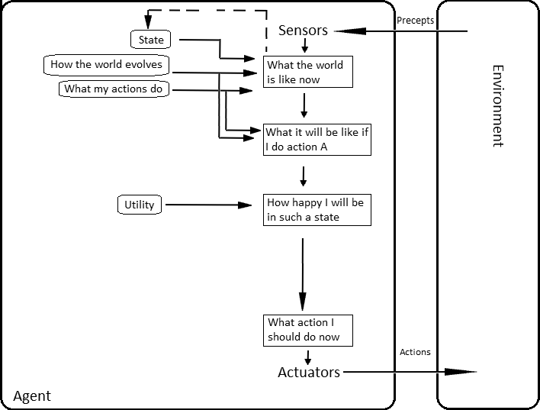

LEARNING AGENT

